**ASSIGNMENTS -1**

**UPDATE AND FIND DOCUMENTS:**

**1.get all documents.**

**>db.movies.find()**

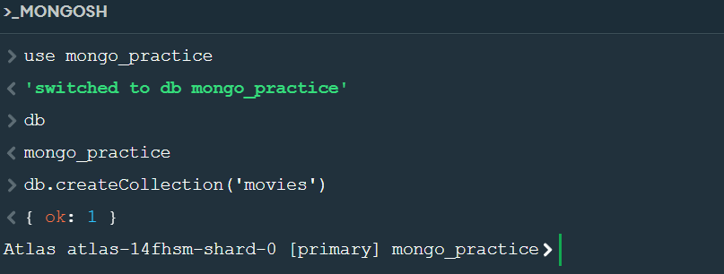

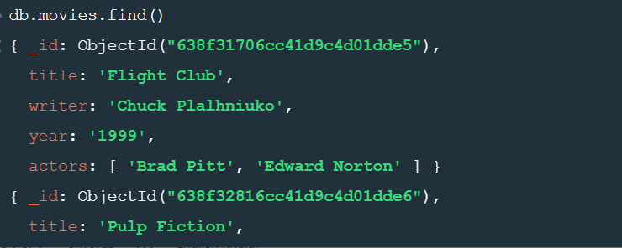

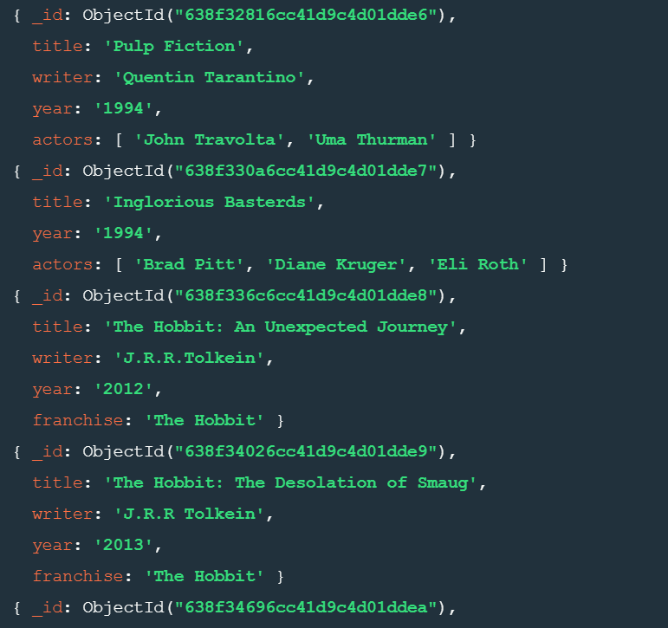

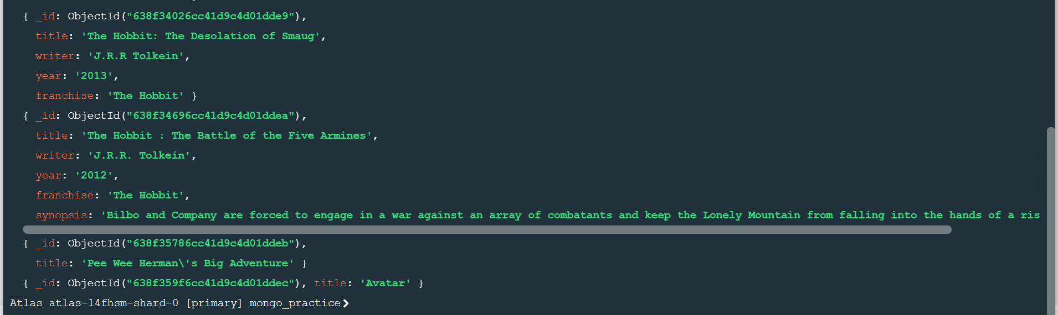

**2.get all documents with writer set to “Quentin Tarantino”.**

**>db.movies.find({writer : “Quentin Tarantino ”})**

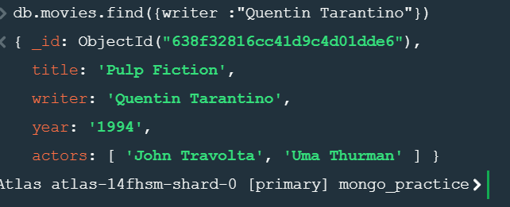

**3.get all documents where actors include “Brad Pitt”**

**>db.movies.find({actors: “Brad Pitt”})**

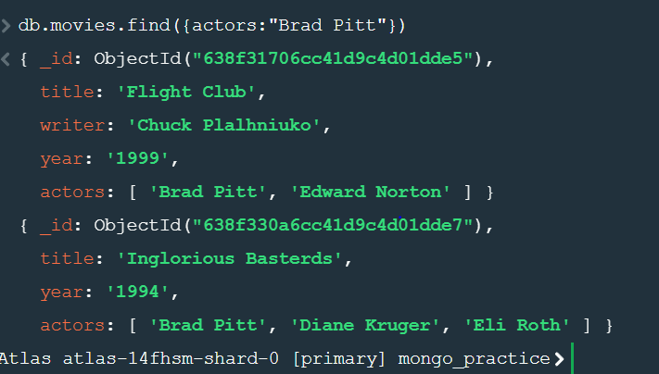

**4.get all documents where franchise set to “The Hobbit”**

**>db.movies.find({franchise: “The Hobbit”})**

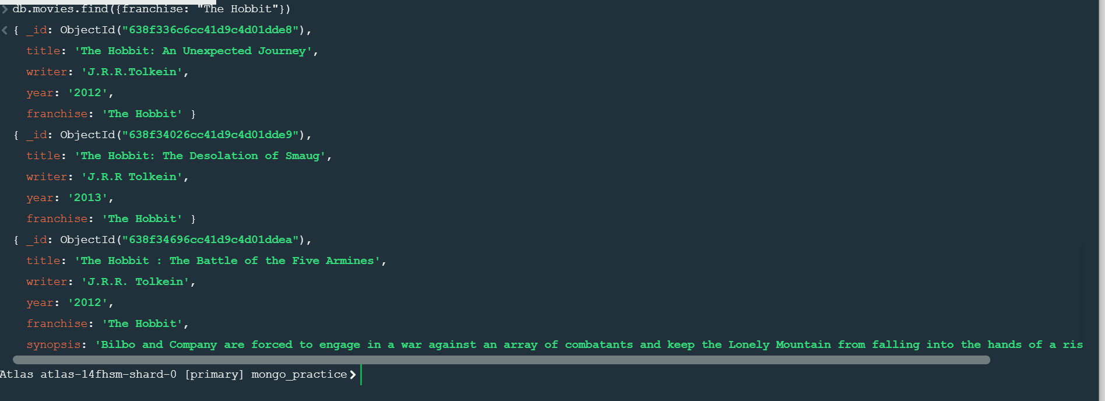

**5.get all movies released in 90’s**

**>db.movies.find({year: {$gt : “1990 “,$lt : “2000”}})**

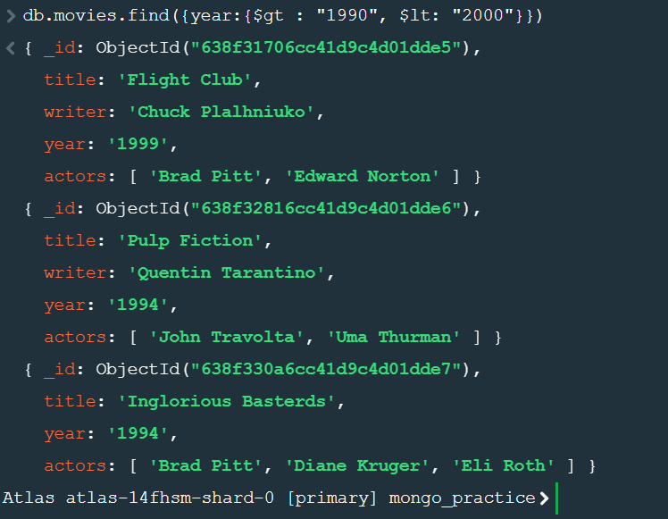

**6.Get all movies released before the year 2000 or after 2010**

**>db.movies.find({$or:[{year: {$gt : “2010”}},{year : {$lt: “2000”}}]})**

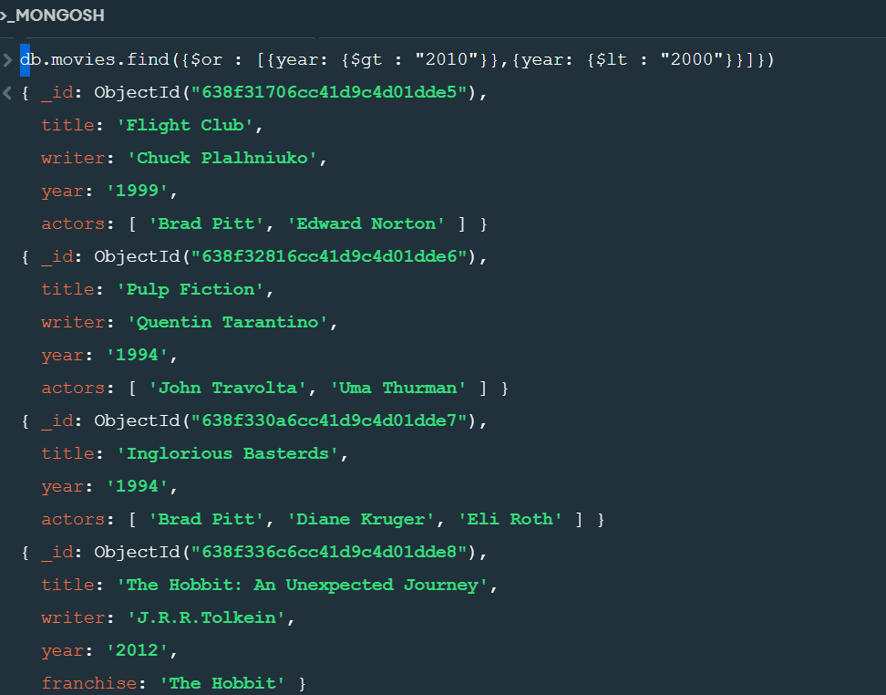

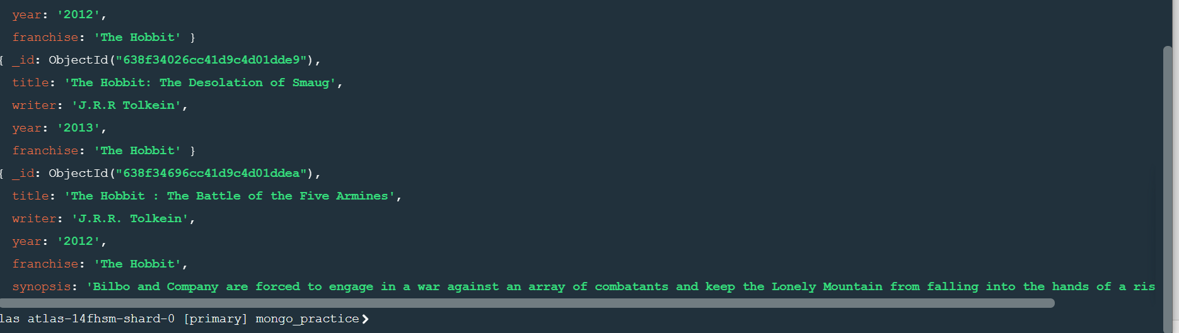

**Update**

**1.add a synopsis to “The Hobbit: An Unexpected Journey”: “A reluctant hobbit, Bilbo Baggins, sets out to the Lonely Mountain with a spirited group of dwarves to reclaim their mountain home – and the gold within it – from the dragon Smaug”.**

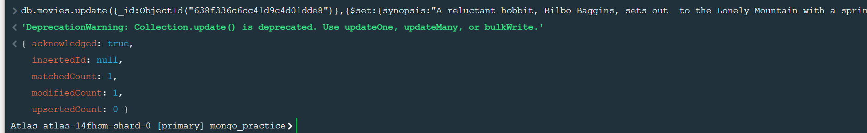

**2.add a synopsis to “The Hobbit: The Desolation of Smaug”: “The dwarves, along with Bilbo Baggins and Gandalf the Grey, continue their quest to reclaim Erabor, their homeland, from Smaug. Bilbo Baggins is in possession of a mysterious and magical ring”.**

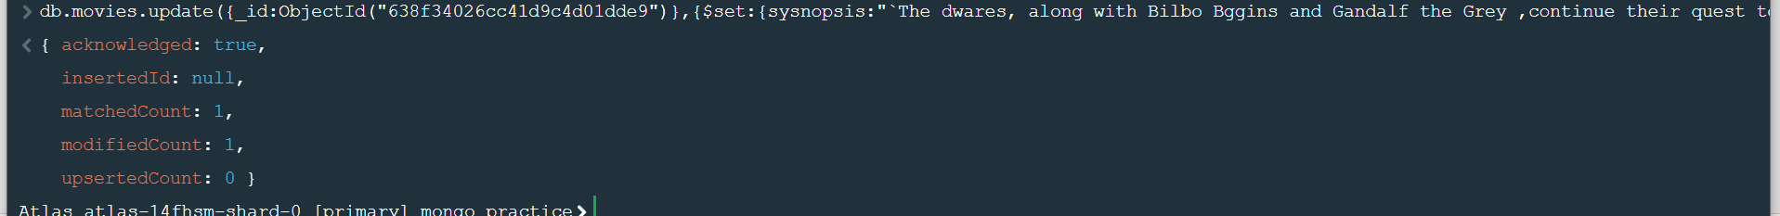

**3.add an actor named “Samuel L. Jackson” to the movie “Pulp Fiction”.**

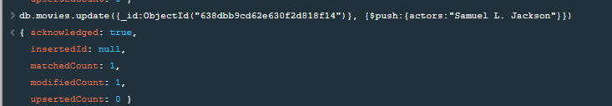

**Text Search**

**1.find all movies that have a synopsis that contains the word “Bilbo”**

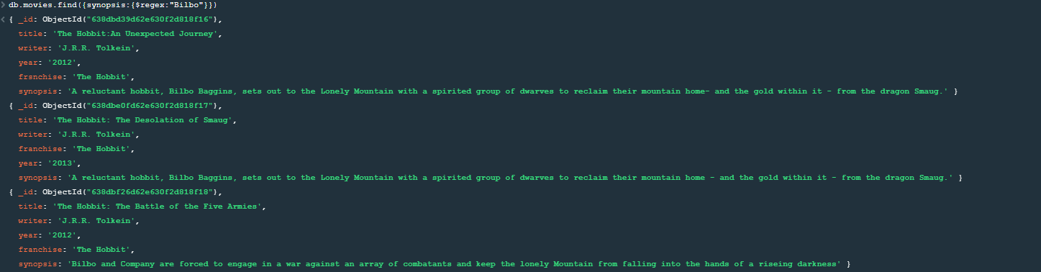

**2.find all movies that have a synopsis that contains the word “Gandalf”**

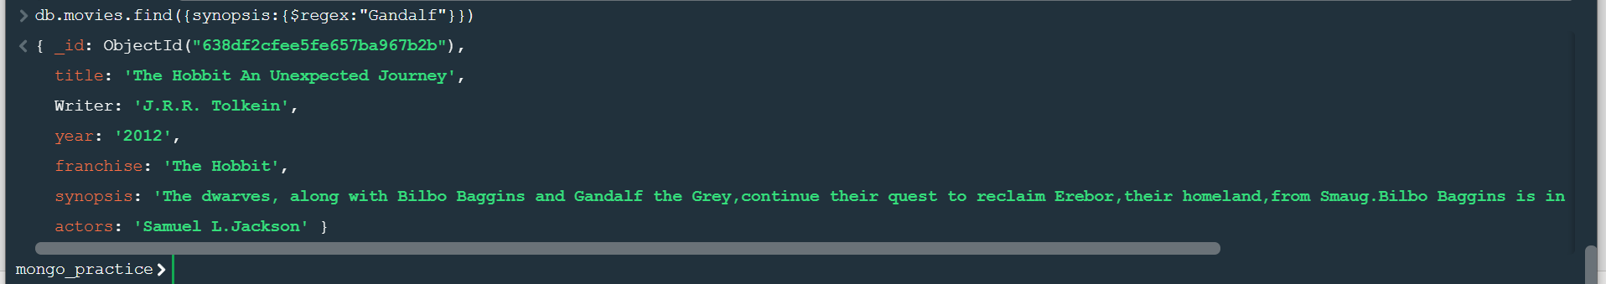

**3.find all movies that have a synopsis that contains the word “Bilbo” and not the word “Gandalf”**

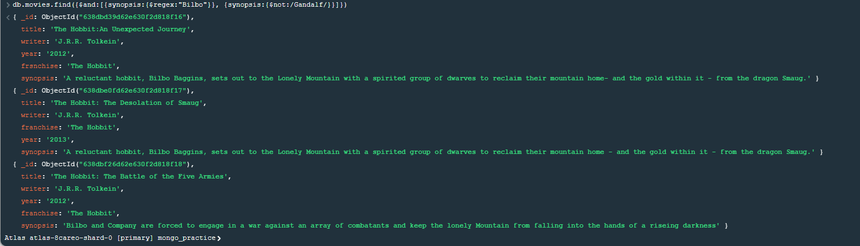

**4.find all movies that have a synopsis that contains the word “dwarves” or “hobbit”**

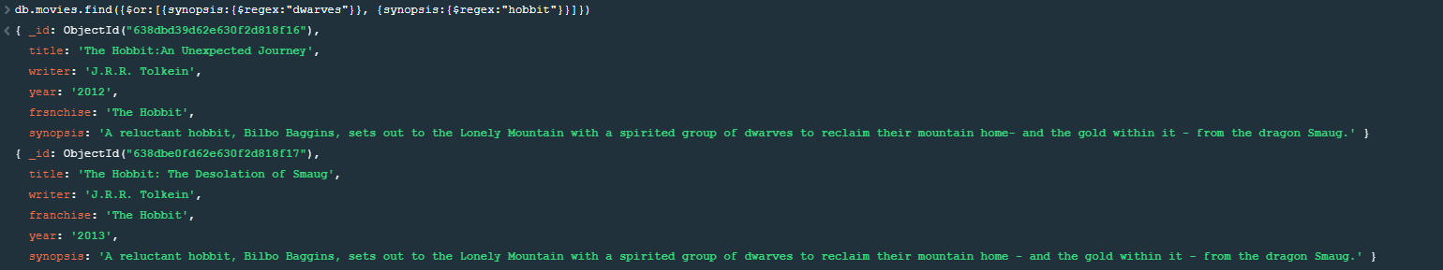

**5.find all movies that have a synopsis that contains the word “gold” and “dragon”**

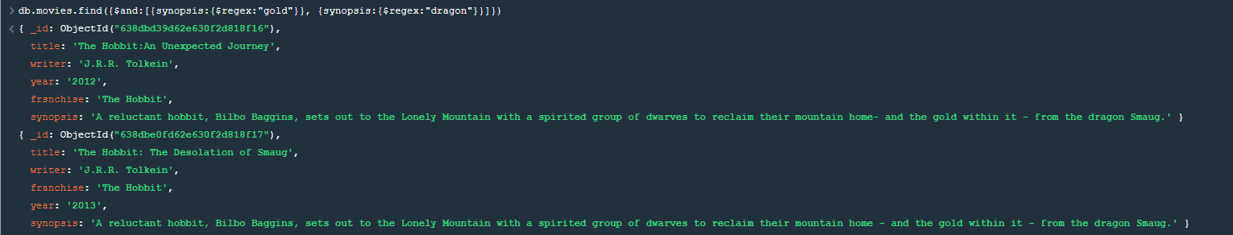

**Delete Documents**

**1.delete the movie “Pee Wee Herman’s Big Adventure”**



**2.delete the movie “Avatar”**



**Querying**

**1.Find all users**

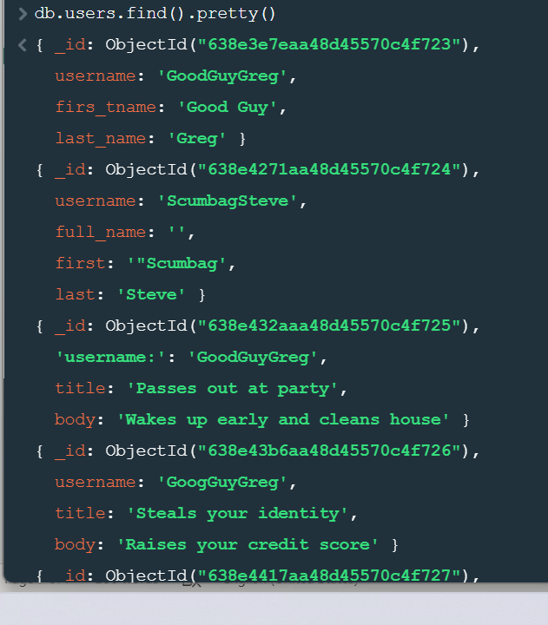

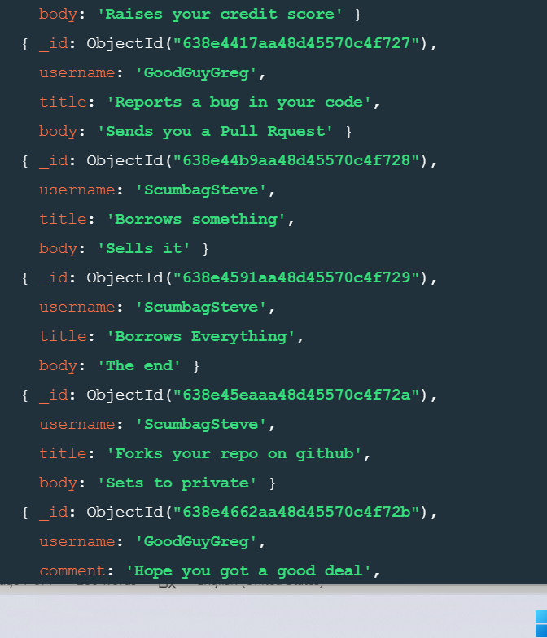

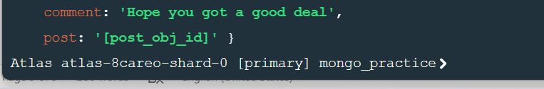

**2.find all posts**

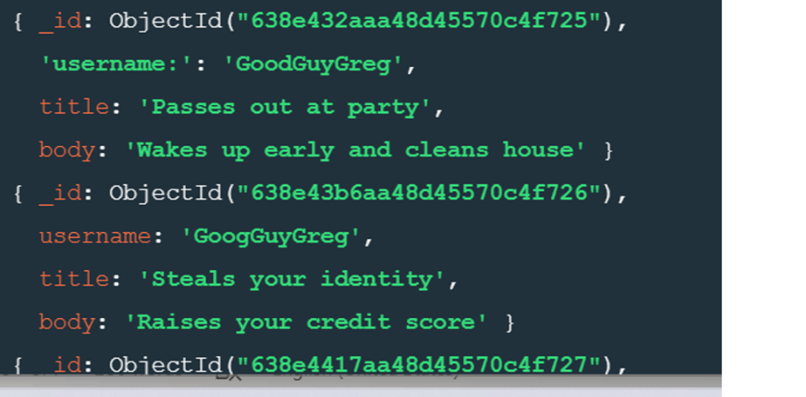

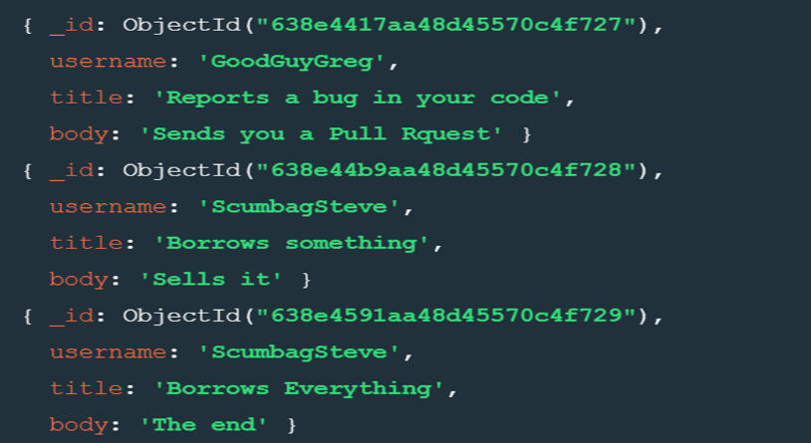

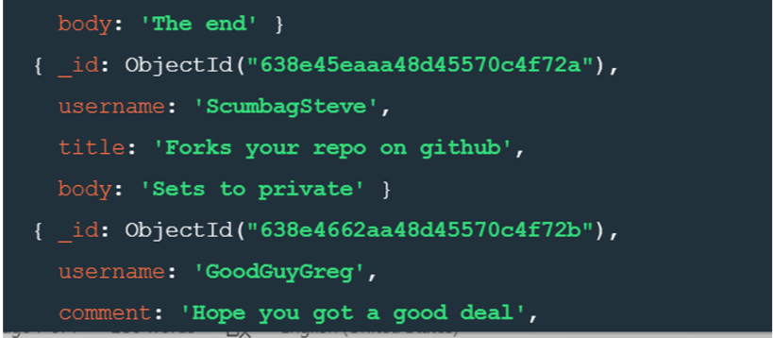

**3.find all posts that was authored by “GoodGuyGreg”.**



**4.find all posts that was authored by “ScumbagSteve”.**



**5.find all comments**

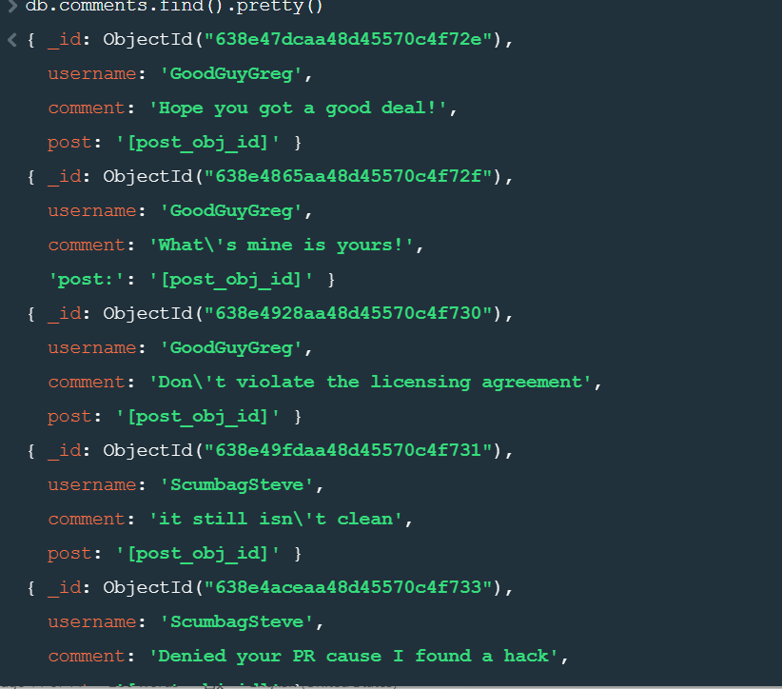

**6.find all comments that was authored by “GoodGuyGreg”.**

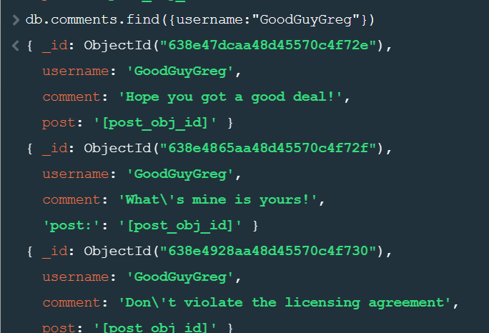

**7.find all comments that was authored by “ScumbagSteve”**

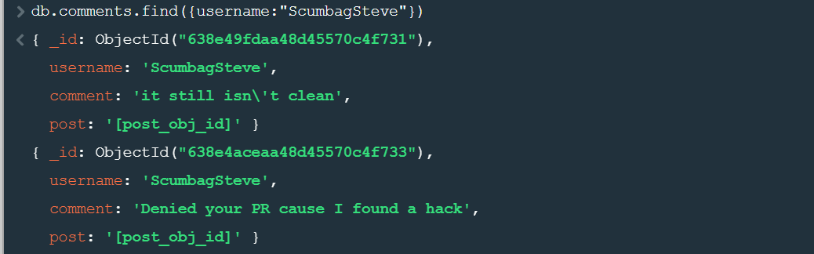

**Assignment-2**

**1.Use db.zipcodes.find() to filter results to only the results where city is ATLANTA and state is GA**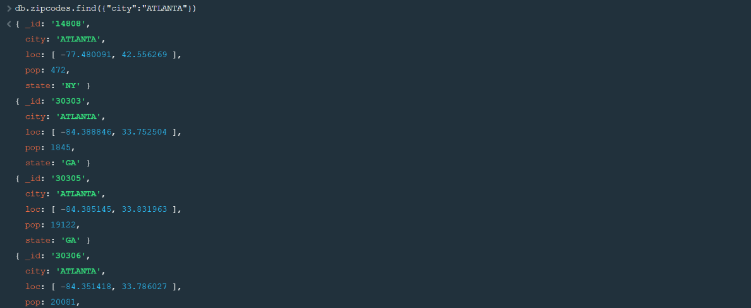

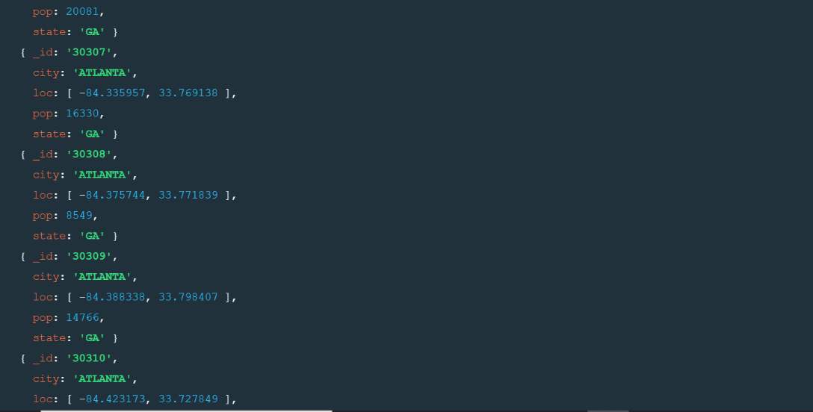

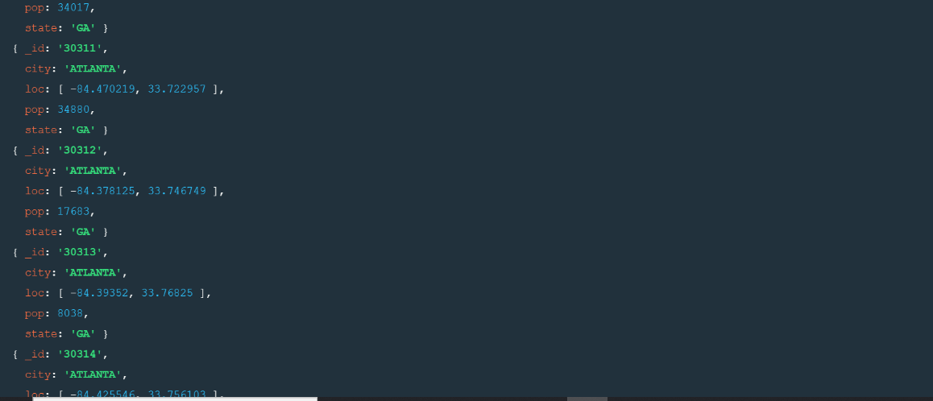

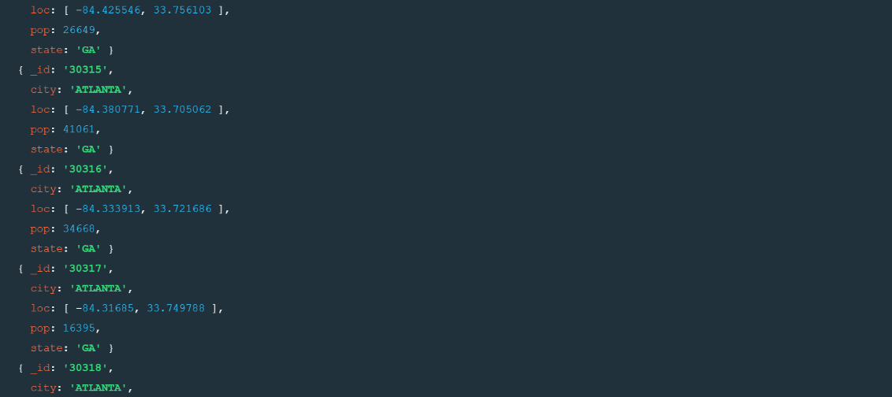

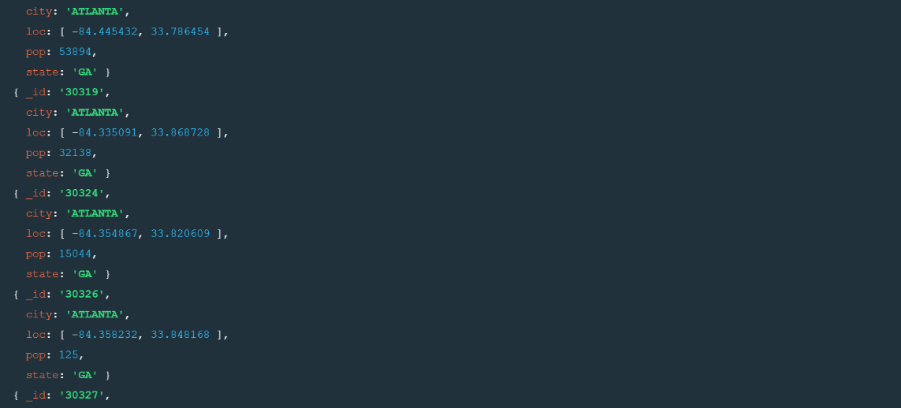

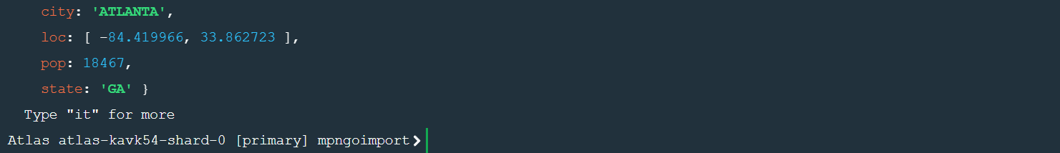

**2.Use db.zipcodes.aggregate with $match to do the same as above.**

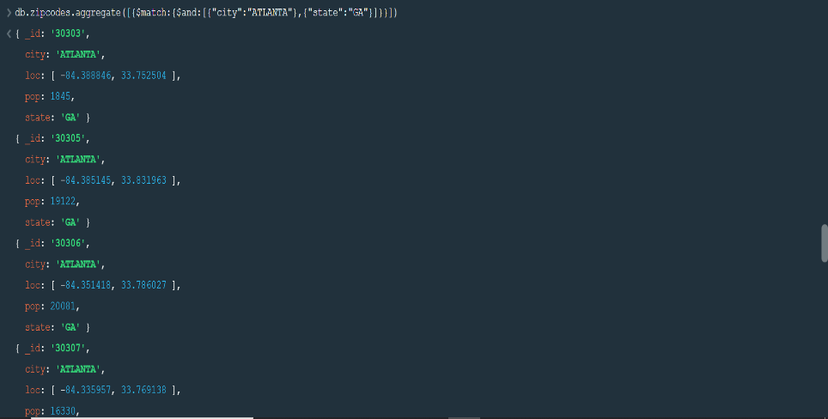

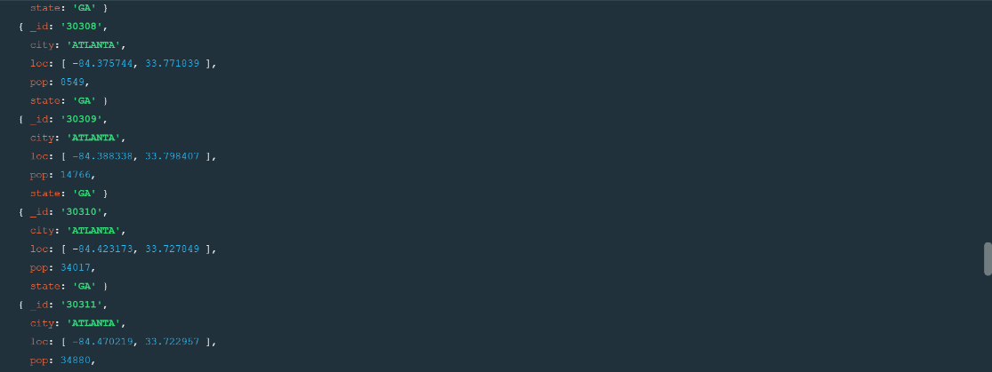

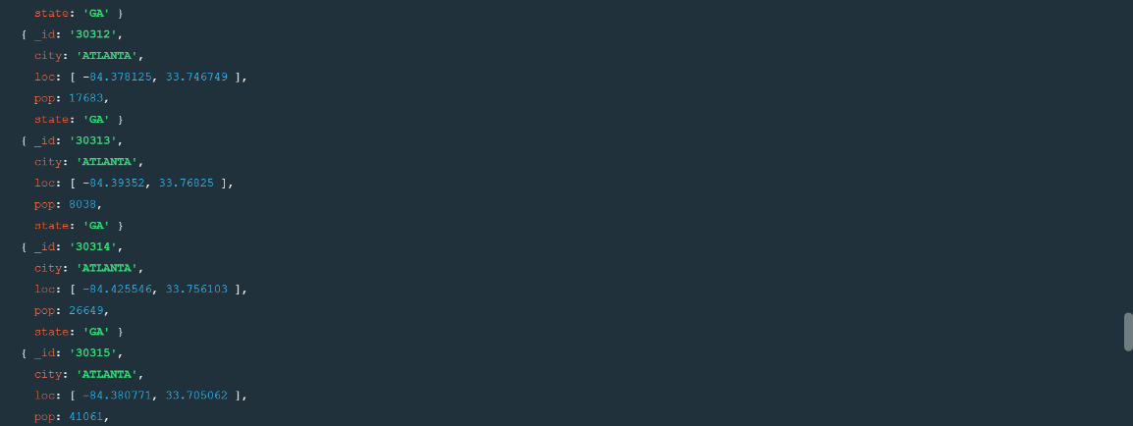

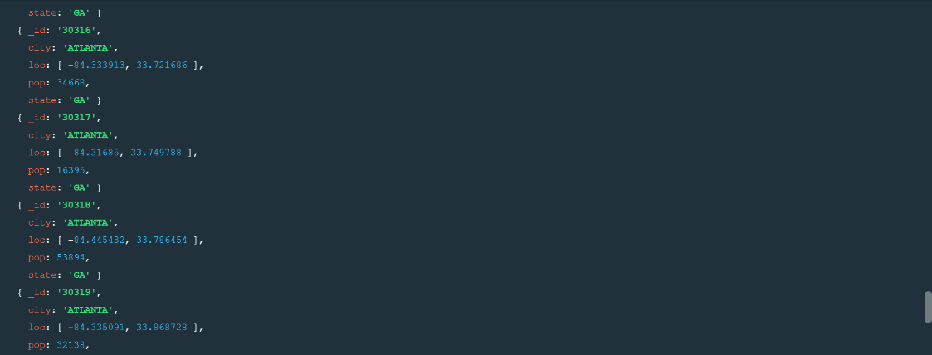

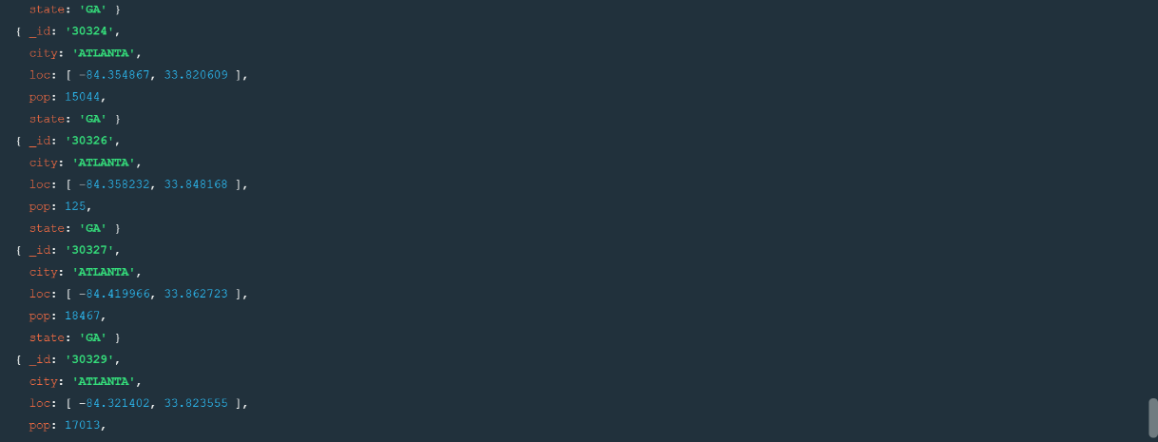



**3.use $group to count the number of zip codes in Atlanta.**



**4.use $group to find the total population in Atlanta.**



**Populations by state**

**1.use aggregate to calculate the total population for each state**



**2.sort the results by population, highest first**

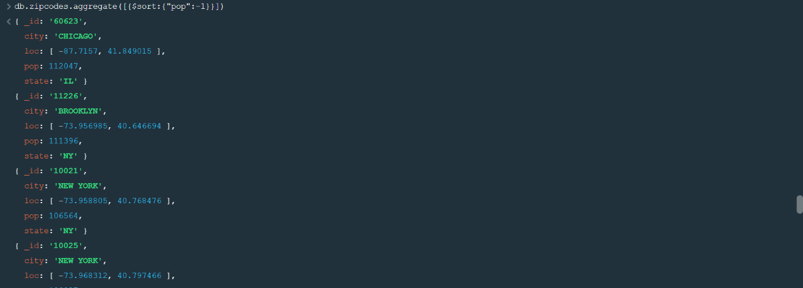

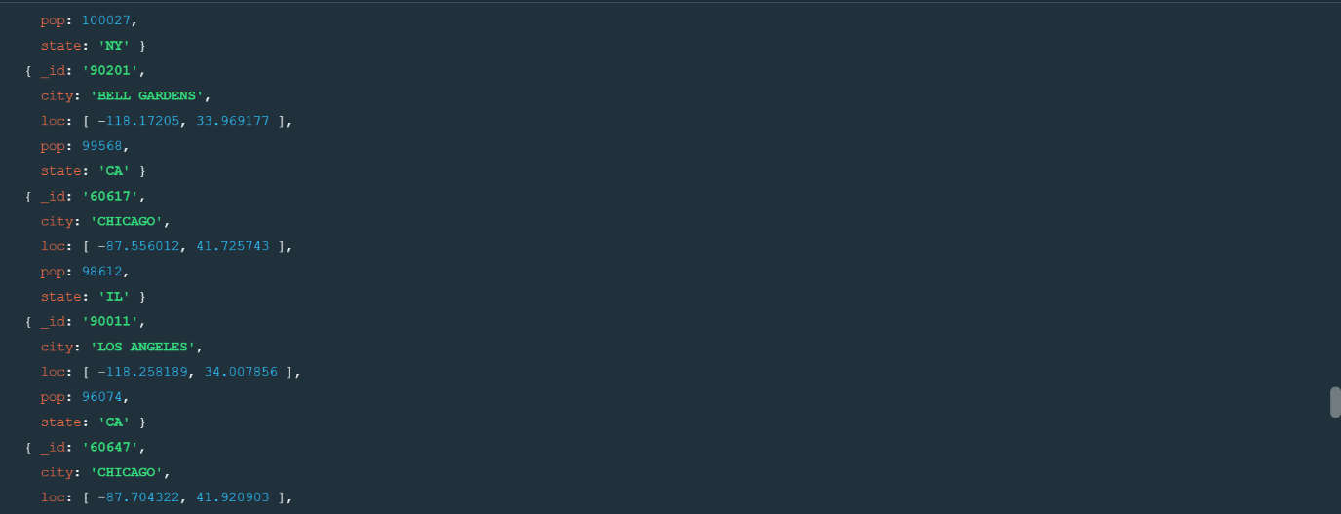

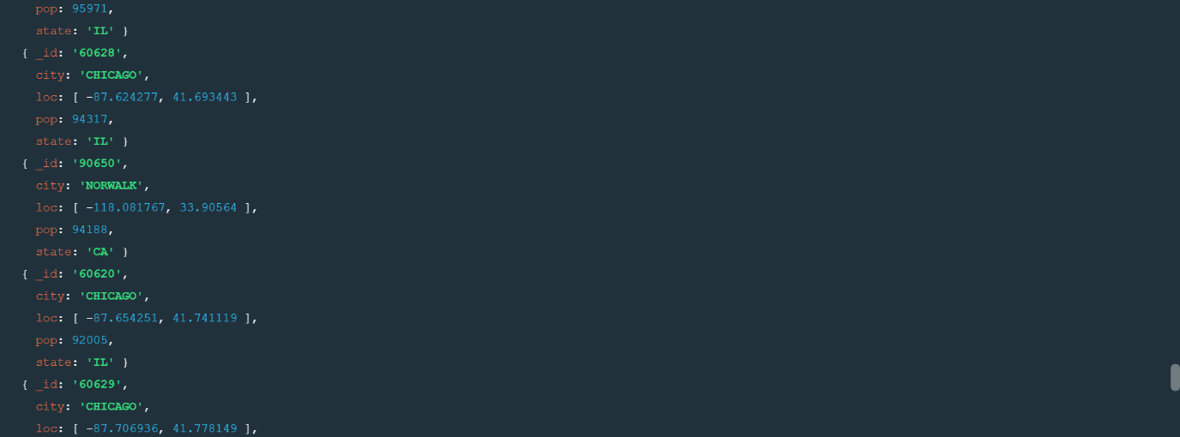

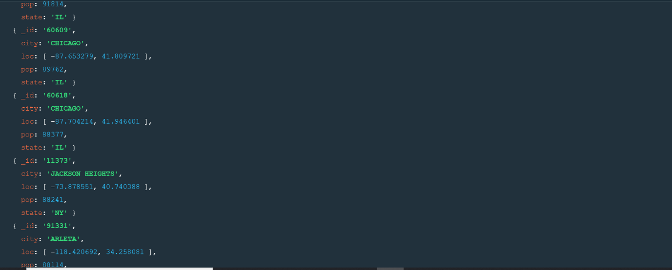

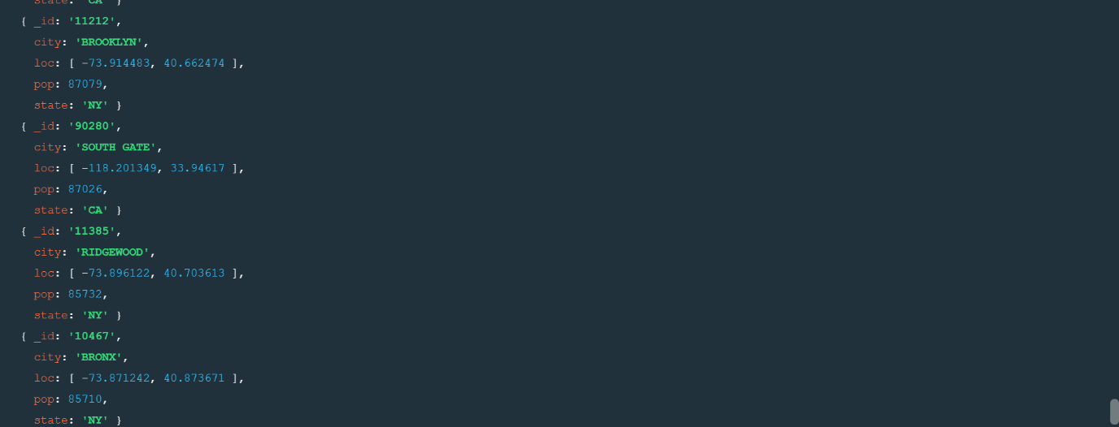

**3.limit the results to just the first 3 results. what are the top 3 states in population?**

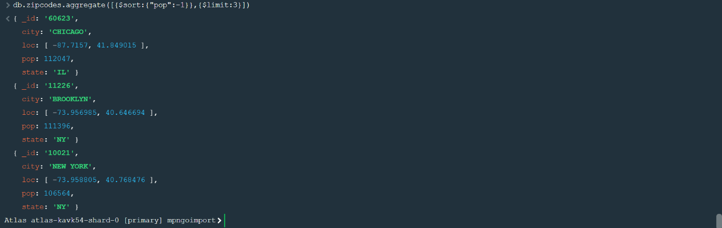

**Populations by city**

**1.use aggregate to calculate the total population for each city (you have to use city/state combination).You can use a combination for the _id of the $group:{city:’$city’, state:’$state’}**



**2.sort the results by population, highest first**

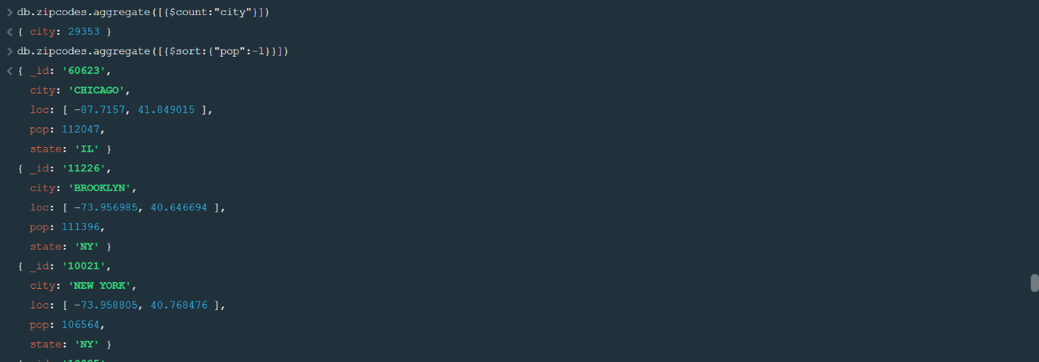

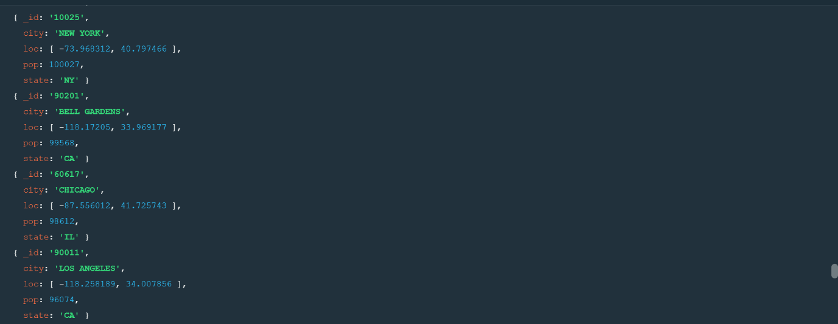

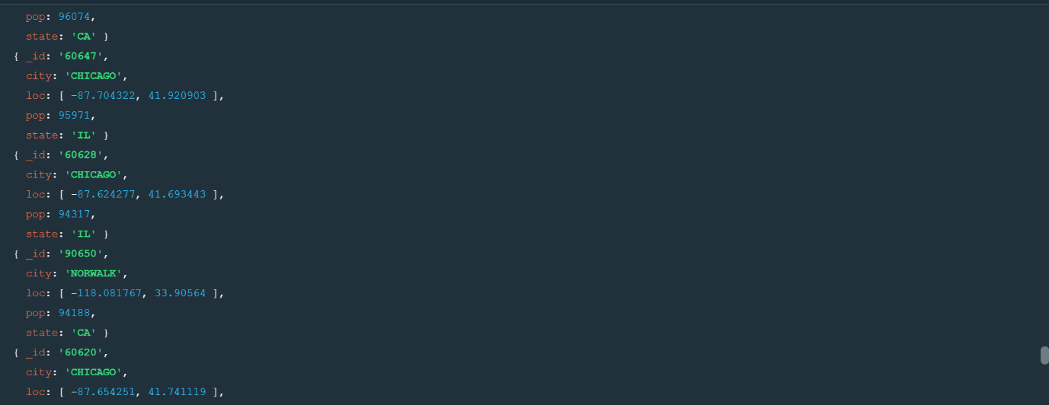

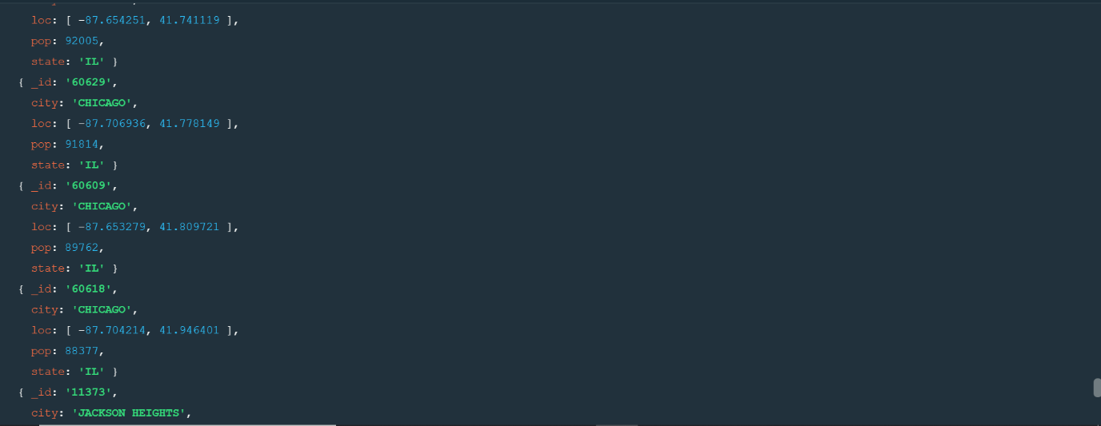

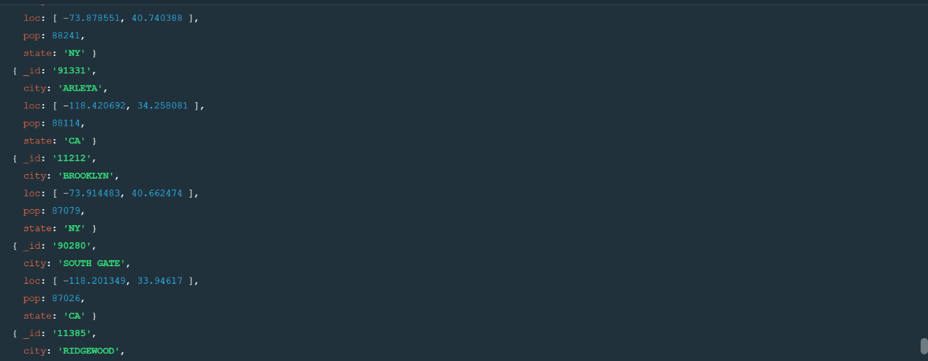

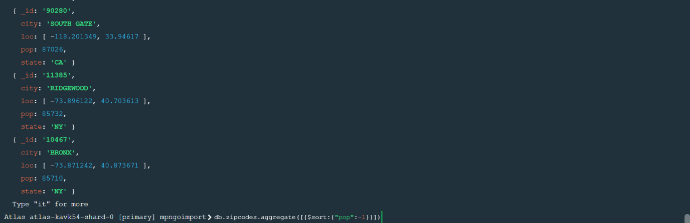

**3.limit the results to just the first 3 results. What are the top 3 cities in population?**

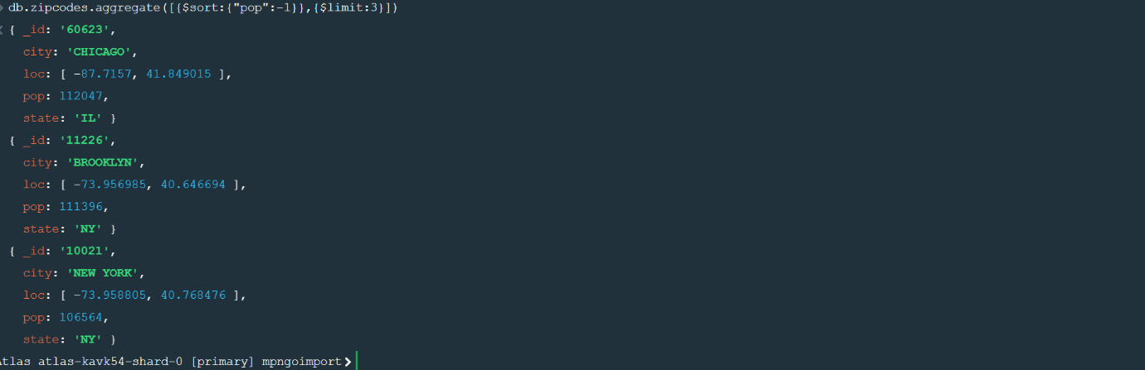

**4.What are the top 3 cities in population in Texas?**

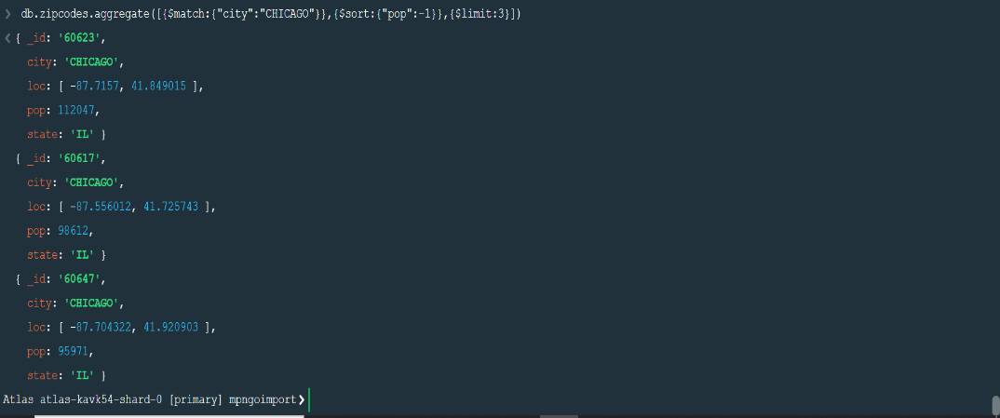

**Assignment-3**

**1.Unzip the file restaurants.zip file**

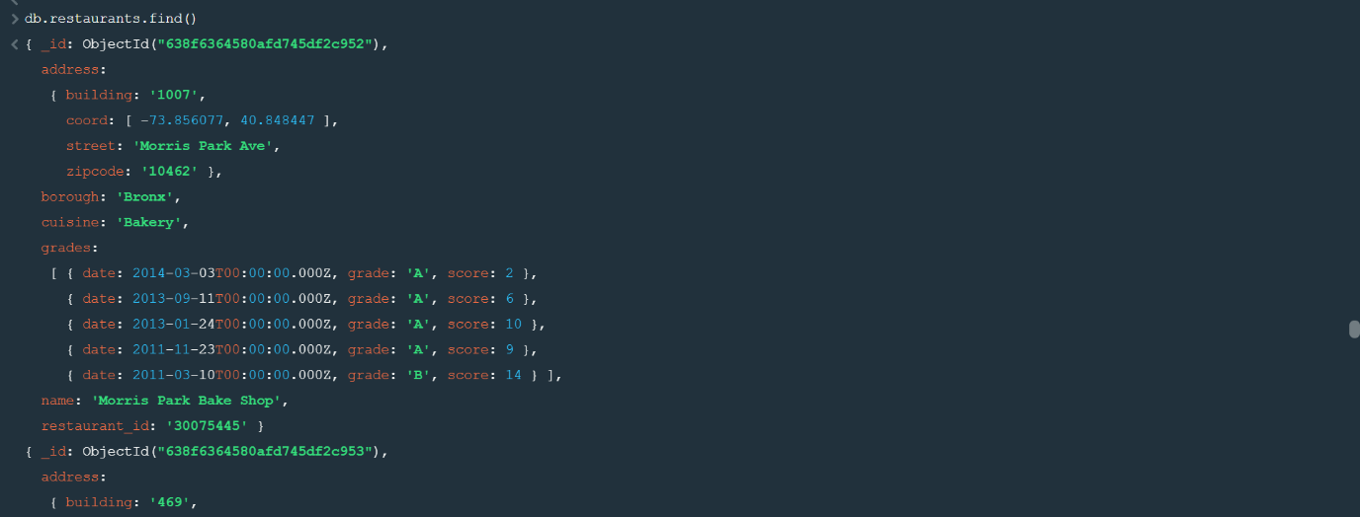

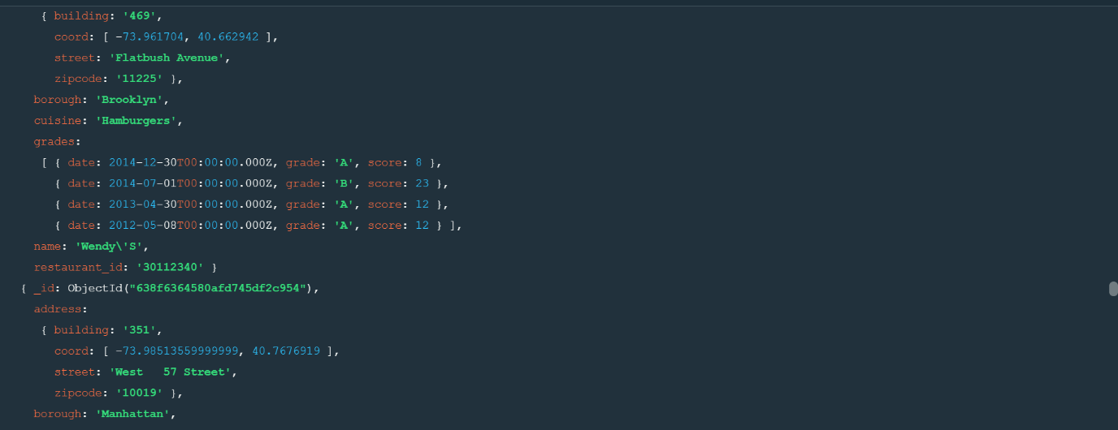

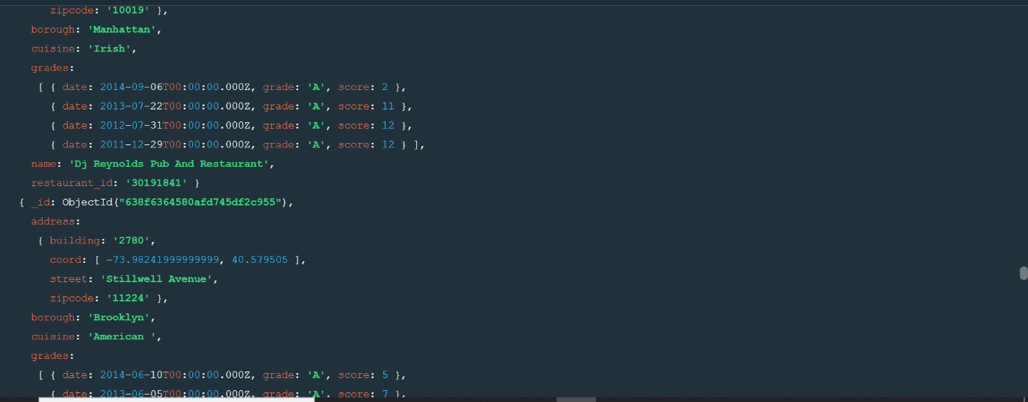

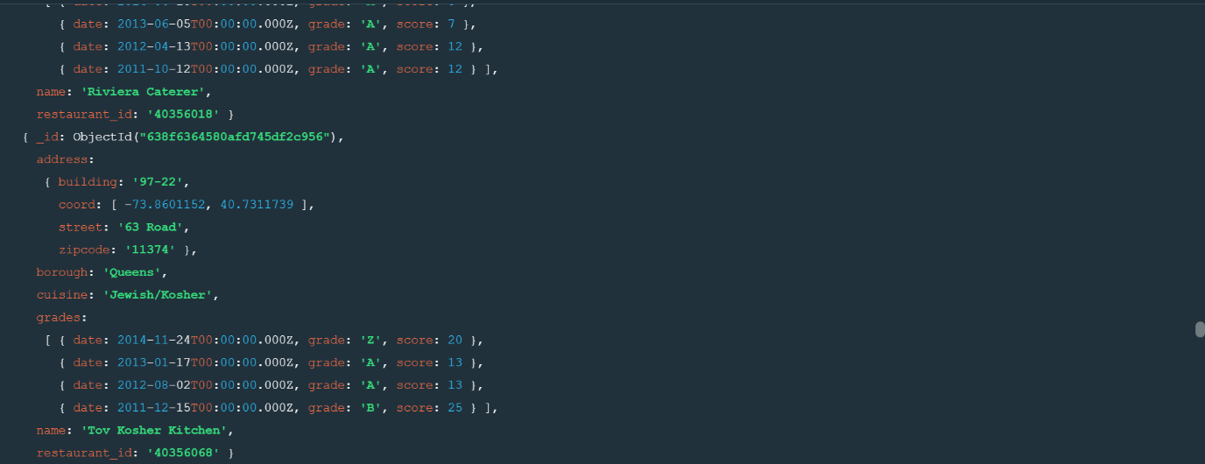

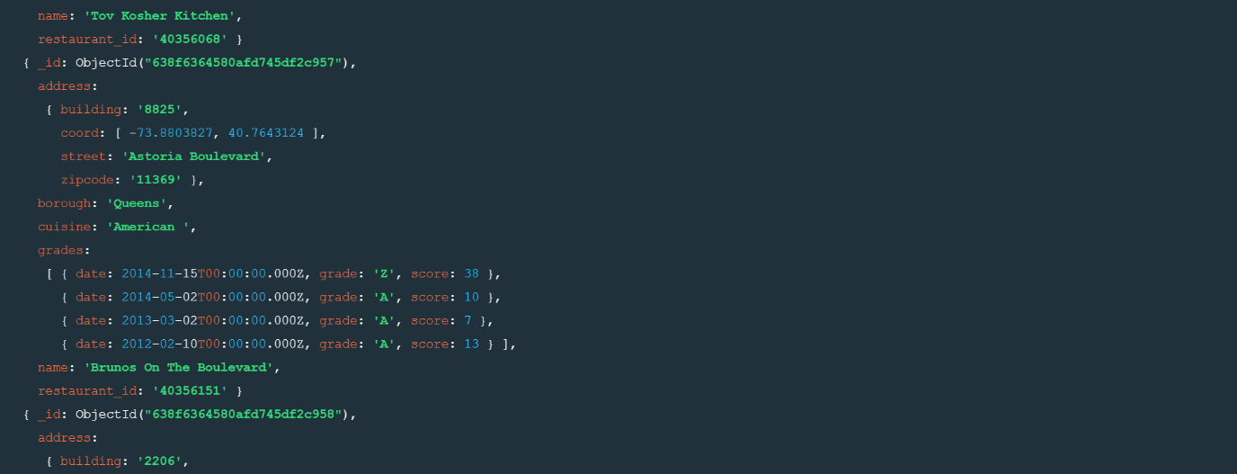

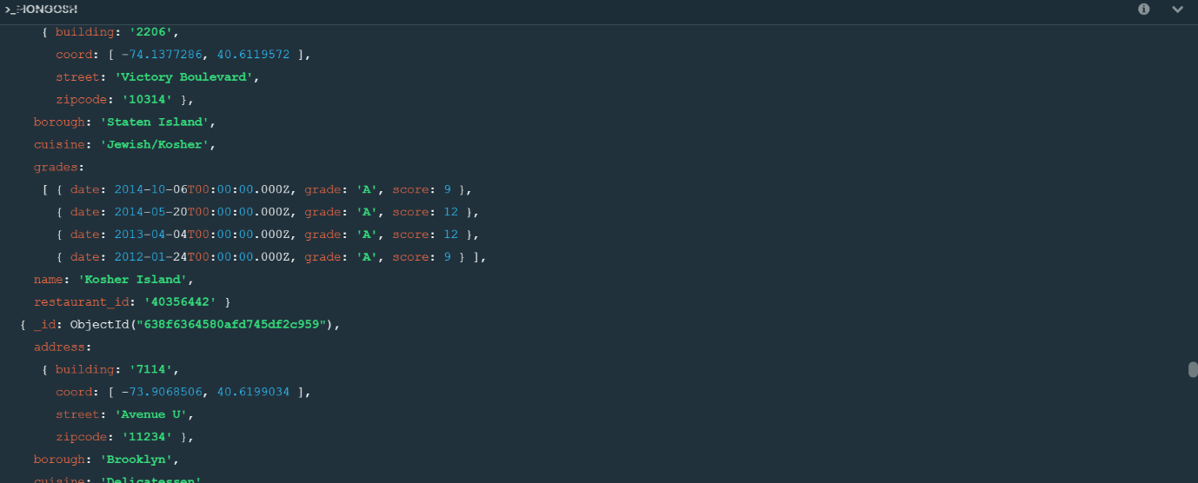

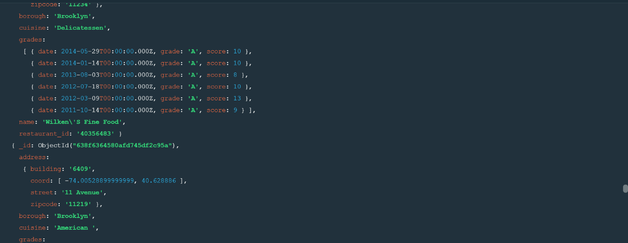

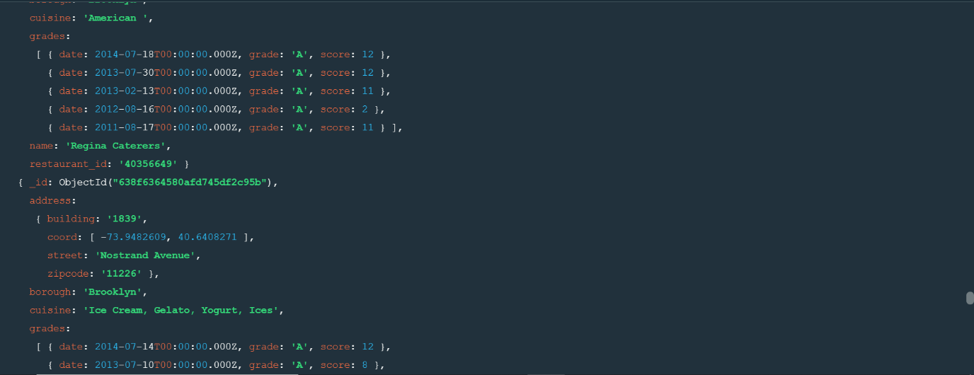

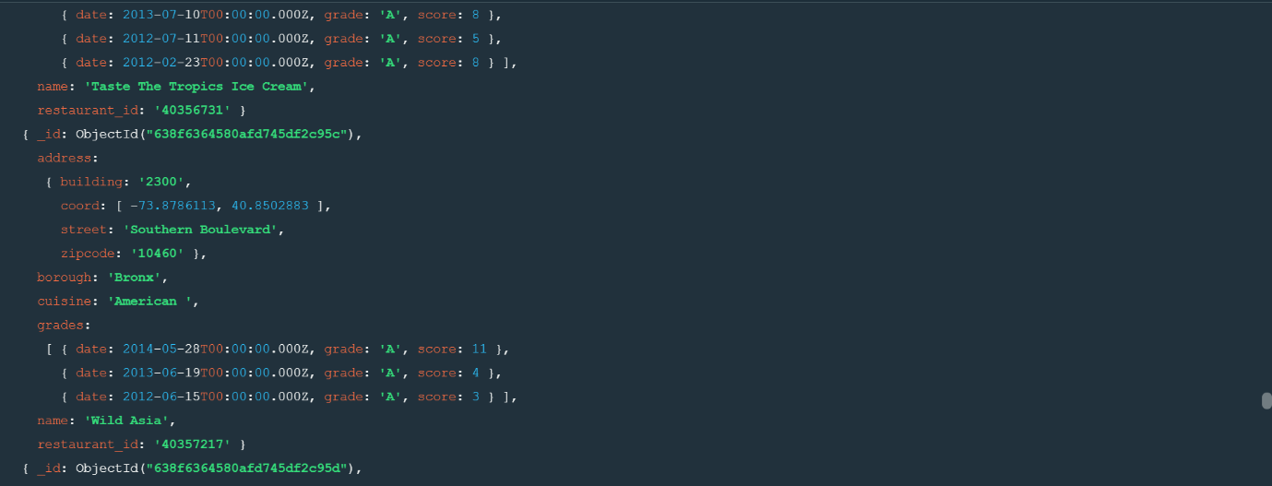

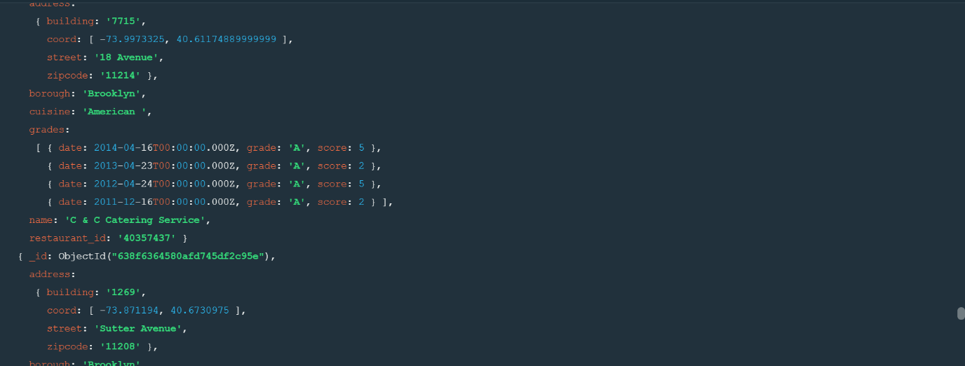

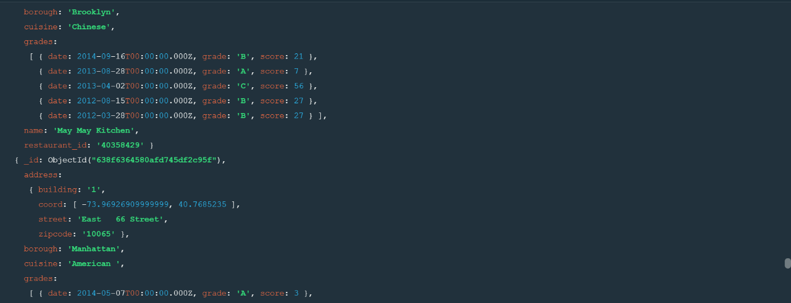

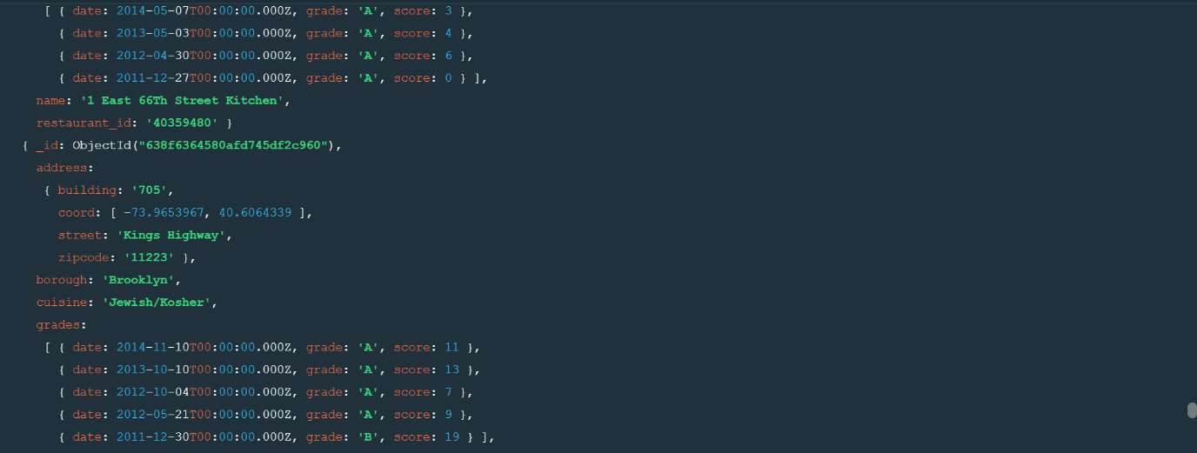

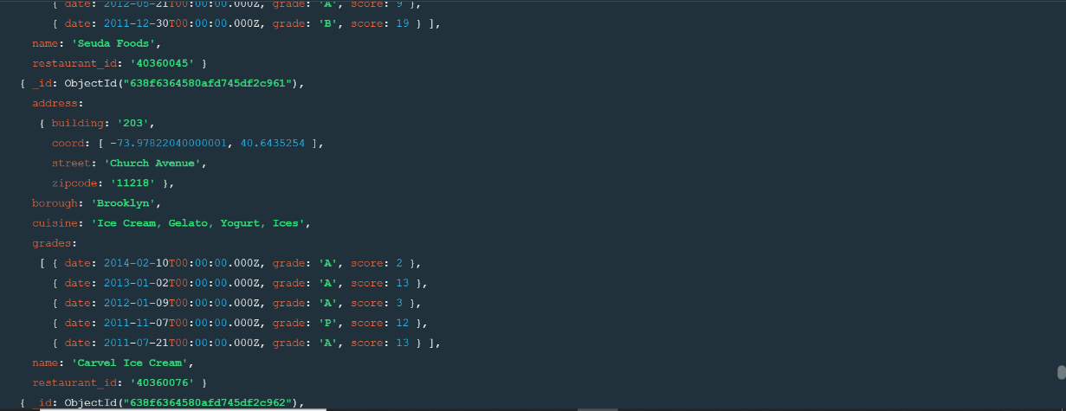

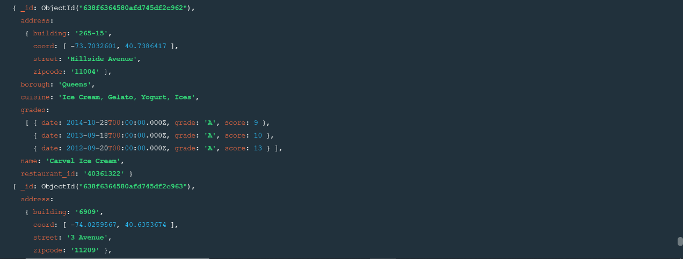

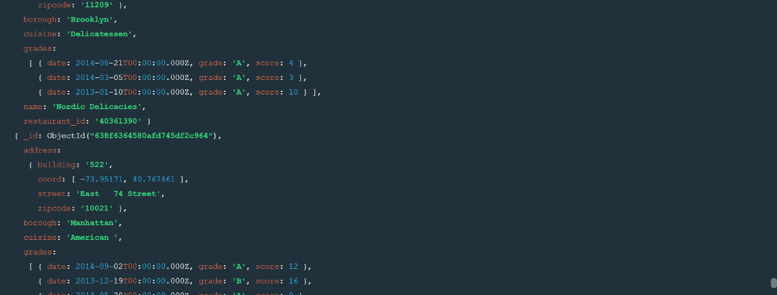

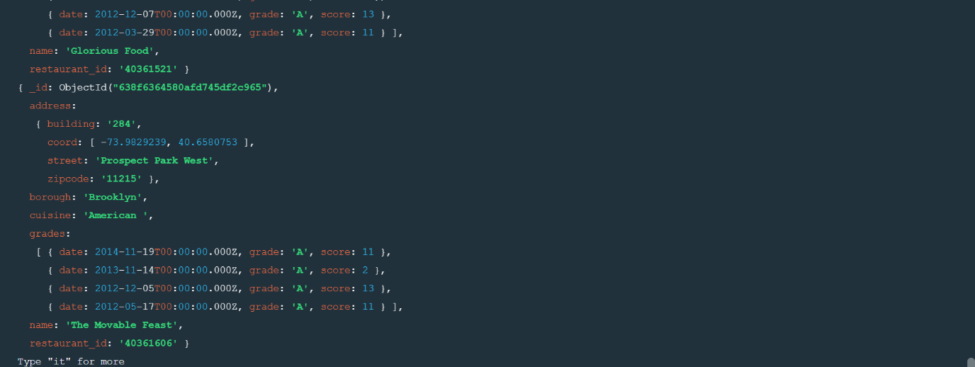

**2.Run the mongod server**

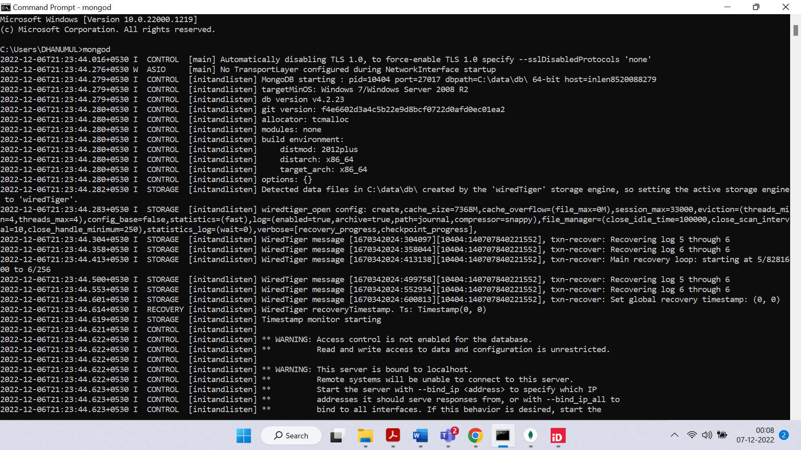

**4.Run mongo shell command**

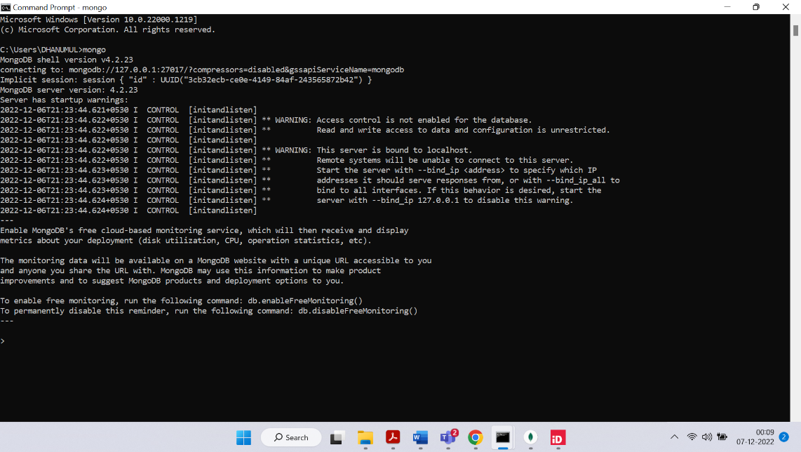

**5.show databases**

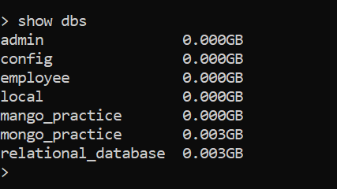

**6.db.addresses.find() should print entire json data**

